C PROGRAMMING
NAME : YOKITHA S
ROLL NO : 241801327
WEEK : 13
TOPIC : PASSING ARRAYS AND STRINGS TO FUNCTIONS

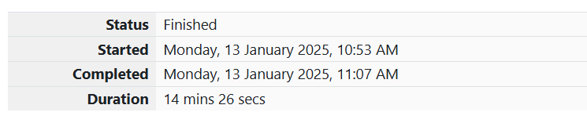1. Problem Statement: Balanced Array
Given an array of numbers, find the index of the smallest array element (the pivot) for which the sums of all elements to the left and to the right are equal. The array may not be reordered.
Example
Array: [1,2,3,4,6][1, 2, 3, 4, 6][1,2,3,4,6]
- The sum of the first three elements is 1+2+3=61 + 2 + 3 = 61+2+3=6.
- The value of the last element is 6.
- Using zero-based indexing, arr[3]=4\text{arr}[3] = 4arr[3]=4 is the pivot.
- The index of the pivot is 3.
Function Description
Complete the function balancedSum with the following parameter:
- int arr[n]: an array of integers.
Returns
- An integer representing the index of the pivot.
Constraints
- 3≤n≤1053 \leq n \leq 10^53≤n≤105
- 1≤arr[i]≤2×1041 \leq \text{arr}[i] \leq 2 \times 10^41≤arr[i]≤2×104
Sample Input
Copy code
4
1 2 3 3
Sample Output
Copy code
2

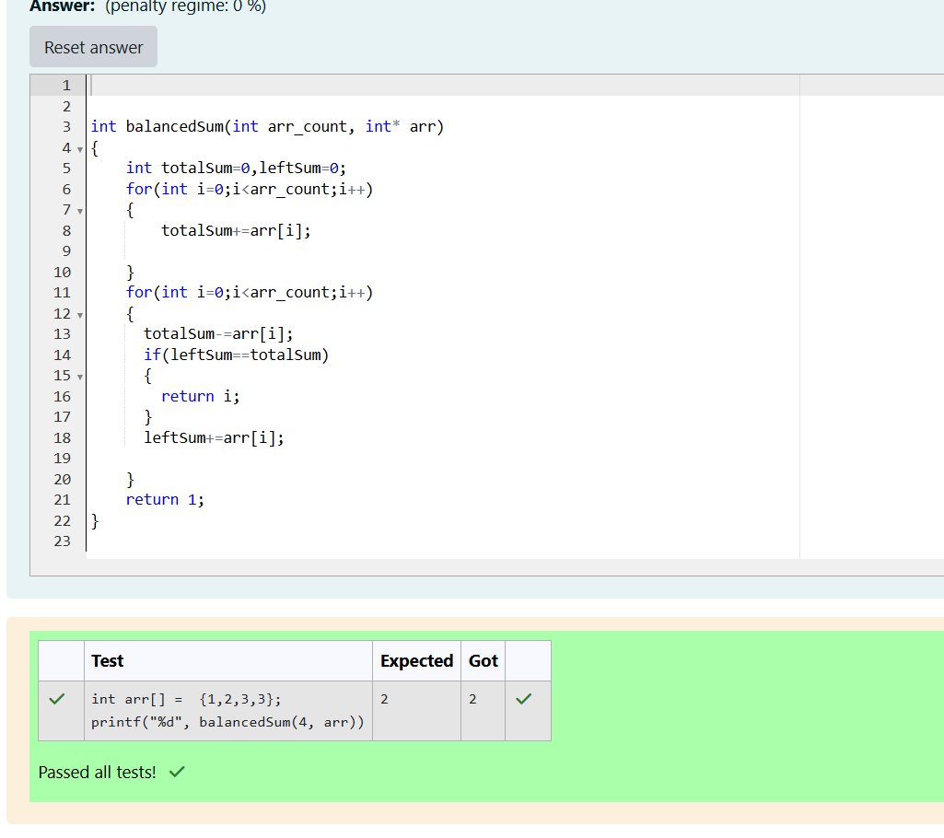

2. Problem Statement: Sum Them All
Calculate the sum of an array of integers.
Example
Array: [3,13,4,11,9][3, 13, 4, 11, 9][3,13,4,11,9]
- The sum is 3+13+4+11+9=403 + 13 + 4 + 11 + 9 = 403+13+4+11+9=40.
Function Description
Complete the function arraySum with the following parameter:
- int numbers[n]: an array of integers.
Returns
- An integer sum of the numbers array.
Constraints
- 1≤n≤1041 \leq n \leq 10^41≤n≤104
- 1≤numbers[i]≤1041 \leq \text{numbers}[i] \leq 10^41≤numbers[i]≤104
Sample Input
Copy code
5
1 2 3 4 5
Sample Output
Copy code
15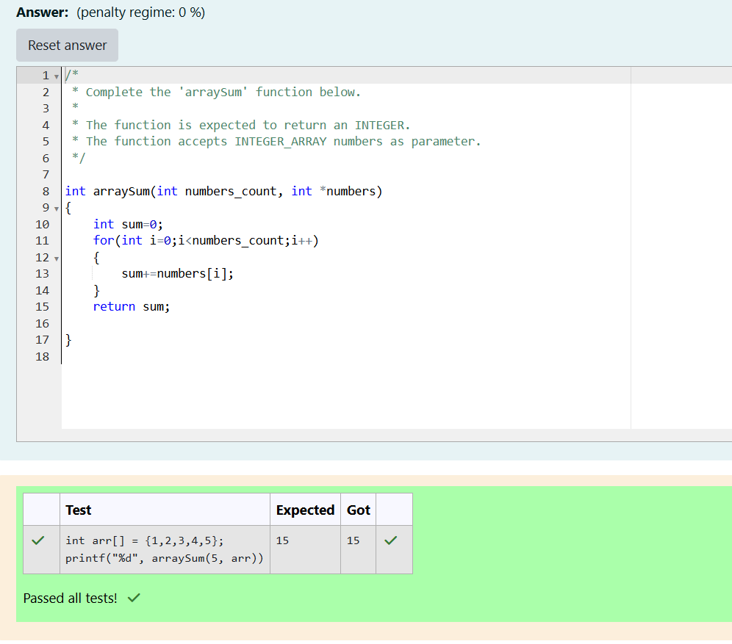

3. Problem Statement: Minimum Difference Sum
Given an array of integers, find the minimum absolute difference between the sum of two non-empty subarrays when you split the array into two contiguous subarrays.
Example
Array: [3,9,7,4][3, 9, 7, 4][3,9,7,4]
- Possible splits: [3][9,7,4][3] [9, 7, 4][3][9,7,4], [3,9][7,4][3, 9] [7, 4][3,9][7,4], [3,9,7][4][3, 9, 7] [4][3,9,7][4]
- The minimum absolute difference between the sums is ∣(3+9)−(7+4)∣=1 |(3+9) - (7+4)| = 1∣(3+9)−(7+4)∣=1.
Function Description
Complete the function minDifferenceSum with the following parameter:
- int arr[n]: an array of integers.
Returns
- An integer representing the minimum absolute difference between the sums of two contiguous subarrays.
Constraints
- 2≤n≤1052 \leq n \leq 10^52≤n≤105
- −104≤arr[i]≤104-10^4 \leq \text{arr}[i] \leq 10^4−104≤arr[i]≤104
Sample Input
Copy code
4
3 9 7 4
Sample Output
Copy code
1

